**MAD PROJECT REPORT**

**BLOOD DONATION APP**

1. **REAL WORLD PROBLEM**

**In a real-world blood donation app, there are several features and functionalities that can help with user identification and verification while ensuring the safety and privacy of both donors and recipients. Here are some common real-world identification methods and practices in a blood donation app**

* **User registration**
* **User verification**
* **Blood type confirmation**

1. **SOLUTIONS**

* **User Registration: Users typically create an account within the app using their personal information, such as name, email address, and phone number.**
* **User Verification: To ensure the authenticity of donors, you can implement various verification methods, such as email verification or phone number verification via one-time passwords (OTPs).**
* **Blood Type Confirmation: Users can confirm their blood type through the app.**

**3)ISSUES AND BUG ENCOUNTERED AND RESOLVED DURING DEVELOPMENT**

* **I faced issues in Data base for fetching data**
* **User Authentication Issues:**

**Bug: Users are unable to register or log in.**

* **Navigation issue**
* **Fire base connection issue**

**4) DATA STORAGE**

* **I used here cloud firestore we can easily store, sync, and query data.**

**5) RESPONSIVE USER INTERFACE**

MOBILE SCREENS

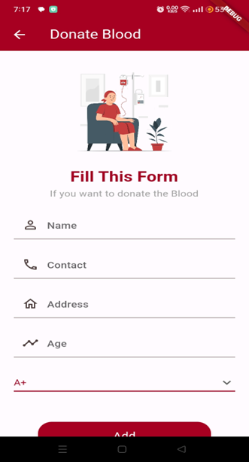

DESKTOP SCREENS



